Pupil Premium Strategy Statement – Zetland Primary School

This statement details our school’s use of pupil premium funding to help improve the attainment of our disadvantaged pupils.
It outlines our pupil premium strategy, how we intend to spend the funding in this academic year and the outcomes for disadvantaged pupils last academic year.

School overview
Detail | Data
Number of pupils in school | 188
Proportion (%) of pupil premium eligible pupils | 37%
Academic year/years that our current pupil premium strategy plan covers | 2025-2028
Date this statement was published | December 2025
Date on which it will be reviewed | December 2026
Statement authorised by | Paul Richardson
Pupil premium lead | Paul Richardson
Governor / Trustee lead | Sheila Leng

Funding overview
Detail | Amount
Pupil premium funding allocation this academic year | £101,820
Pupil premium funding carried forward from previous years | £0
Total budget for this academic year | £101,820

Part A: Pupil premium strategy plan

Statement of intent
Intent
At Zetland, our core aim is for pupil premium children to achieve attainment levels in line with their peers, narrowing the gap from their often significantly lower starting points. We prioritise building strong foundations in reading from the early years, fostering a lifelong love of reading across the school. We recognise the importance of early language acquisition and communication skills as key drivers of future success. Our approach is rooted in equity, ensuring every child—regardless of background—has the opportunity to thrive academically, socially, and emotionally.
Implementation
- Early Years Focus: Emphasis on phonics, vocabulary development, and oral language to build strong reading foundations.
- Targeted Interventions: Carefully planned and monitored support for children needing to make accelerated progress, including pre-teaching and consolidation sessions.
- Challenge for High Potential Pupils: Opportunities for depth and mastery are provided for disadvantaged pupils who require further challenge.
- Additional Adult Support: TA support enables ‘in the moment’ intervention and personalised learning opportunities.
- Emotional and Social Support: Provision to ensure children feel safe, secure, and happy, including pastoral care and wellbeing initiatives.
Impact
- Academic Progress: Disadvantaged pupils make accelerated progress, narrowing the attainment gap.
- Language and Literacy: Improved early communication and reading outcomes lead to sustained academic success.
- Equity in Challenge: High-attaining disadvantaged pupils are supported to reach greater depth.
- Wellbeing and Engagement: Pupils feel emotionally supported, leading to improved attendance, behaviour, and engagement in learning.

Challenges
This details the key challenges to achievement that we have identified among our disadvantaged pupils.
Challenge number | Detail of challenge
1 | Low attendance and persistent absence among disadvantaged pupils: Attendance is below national expectations; persistent absence disproportionately affects disadvantaged and SEND pupils and reduces curriculum access.
2 | Low entry levels to school (Early Years): Reception/Nursery baseline is low overall; GLD 2025 = 64% (below national 68%). A substantial proportion of pupils (41% of cohort in EYFS) are disadvantaged; language and communication deficits reduce readiness to access Phonics and early reading.
3 | Phonics, early reading and Key Stage 1 outcomes: Y1 Phonics for disadvantaged pupils is 57% (below national Other 83% and below national disadvantaged benchmarks). Vulnerable readers need swift, evidence-based catch-up to avoid later gaps.
4 | Lower outcomes in combined RWM and subject-specific gaps at KS2 / KS1: 2025 RWM combined for disadvantaged 38% vs National Other 70% — large attainment gap in core subjects, particularly maths and writing for disadvantaged pupils.
5 | Social, emotional & mental health (SEMH) and behaviour: Increasing numbers with SEMH needs (including high levels of social care / Early Help). SEMH needs reduce engagement, concentrate difficulties, and limit learning.
6 | Limited life experiences and cultural capital: High local deprivation (IDACI data) means many disadvantaged pupils have restricted extracurricular and cultural learning opportunities which reduces engagement, vocabulary and curriculum knowledge.

Intended outcomes
This explains the outcomes we are aiming for by the end of our current strategy plan, and how we will measure whether they have been achieved.
Intended outcome | Success criteria
A. Improve attendance and reduce persistent absence | Whole-school attendance: Aim for 94.8% or higher by July 2026.  Persistent absence: Reduce the number of disadvantaged pupils missing 10% or more sessions to be closer to national averages.  Support for chronic absence: Each term, ensure pupils with ongoing attendance issues have clear multi-agency plans in place and show evidence of improved family engagement (e.g., meeting records, home-school plans).
B. Raise Early Years readiness and GLD for disadvantaged pupils | Reception GLD (Good Level of Development):  Increase from 64% to at least 68% within one year.  Disadvantaged pupils in Reception:  Achieve national disadvantaged averages within two years, or make at least 6 months of accelerated progress, measured by internal EY trackers.
C. Improve early reading and Y1 Phonics outcomes for disadvantaged pupils | Year 1 Phonics Check (Disadvantaged Pupils):  Increase pass rate from 57% to at least the national disadvantaged benchmark (≥67%) within one year.  Targeted Phonics Interventions:  Pupils in interventions show measurable progress, assessed every 6 weeks, with an average impact of +4 to +8 months (based on EEF guidance).
D. Increase attainment in RWM for disadvantaged pupils | Increase the percentage of disadvantaged pupils achieving the year-group expected standard so that the attainment gap closes.  The proportion of disadvantaged pupils achieving Greater Depth or high scores should increase every term.
E. Improve SEMH, behaviour and engagement | Reduce logged behavioural incidents for targeted disadvantaged pupils, or show improvement using social-emotional learning (SEL) baseline tools.  Increase disadvantaged pupils’ participation in class and extracurricular activities.  Record positive changes in wellbeing through pastoral notes and wellbeing measures.

Activity in this academic year
This details how we intend to spend our pupil premium funding this academic year to address the challenges listed above.

Teaching (for example, CPD, recruitment and retention)
Budgeted cost: £ 33,798
Activity | Evidence that supports this approach | Challenge number(s) addressed
1. Whole-school CPD programme on adaptive teaching, formative assessment and high-impact classroom strategies Focus on differentiating in‑lesson for pupils with gaps, and building teacher confidence to implement adaptive moves in real time. (Tier 1: Professional development & adaptive teaching) | EEF guidance highlights that well-designed professional development and implementation support are central to improving teaching quality and sustaining change (see EEF resources, Guide to Pupil Premium & Implementation). See: EEF – Guide to the Pupil Premium and evidence resources and EEF implementation resources referenced on the site. | 2,3,4,5
2. Continue to embed the Little Wandle, high‑quality synthetic phonics programme across Reception and KS1 with regular fidelity checks and additional training for staff new to the programme. Ensure decodable-book alignment and frequent assessment to group responsively. (Tier 1: Curriculum & resources) | EEF – Phonics (Teaching and Learning Toolkit): systematic synthetic phonics has a strong evidence base (+5 months) and is particularly effective for disadvantaged pupils. See: EEF – Phonics | 2,3,4,5
3. Embed evidence-based early language provision in Nursery and Reception: adopt Oracy language programmes for Reception children identified through screening. Train TAs and EY staff to deliver small-group language sessions. (Tier 1: Curriculum & pedagogy in EY) | EEF – Oral language interventions (very high impact, +6 months) and EEF Promising Programme NELI (evaluations show reliable gains for Reception children). See: EEF – Oral language interventions and EEF – NELI (Nuffield Early Language Intervention) | 2,3,4,5
4. Strengthen subject leadership and curriculum monitoring across the wider curriculum (responding to Ofsted): implement termly subject leader monitoring cycles, with clear success criteria, pupil voice sampling and adjustment plans to secure curriculum coverage and progression. (Tier 1: Curriculum leadership & assessment) | EEF resources on implementation and curriculum planning emphasise the need for subject-leader monitoring and the evidence-to-practice cycle. See: EEF – Guide to the Pupil Premium and implementation materials | 2,3,4,5
5. Training and best-practice deployment for Teaching Assistants (TAs): focused training for TAs to deliver structured small-group phonics and language sessions and to support classroom adaptive teaching. (Tier 1: Staff deployment & PD) | EEF guidance identifies well-trained TAs delivering targeted interventions can be effective; see EEF resources on making best use of TAs and the Teaching and Learning Toolkit context for small-group delivery (phonics, oral language). See: EEF – Oral language interventions and EEF TA guidance (see Guide to Pupil Premium resources). | 2,3,4,5

Targeted academic support (for example, tutoring, one-to-one support, structured interventions)
Budgeted cost: £ 42,962
Activity | Evidence that supports this approach | Challenge number(s) addressed
1. Reception targeted language groups for children below language thresholds delivered by trained TAs (Tier 2: Targeted intervention) | EEF – NELI: EEF trials show Reception pupils make additional months’ progress; oral language interventions have a very high impact (+6 months). See: EEF – NELI (Nuffield Early Language Intervention) and EEF – Oral language interventions | 2,3,4
2. Rapid, structured small-group phonics catch-up for Y1 disadvantaged pupils and Y2 pupils who did not meet the check Use assessment every 6 weeks to move pupils between groups. (Tier 2: Structured interventions) | EEF – Phonics evidence: targeted intensive phonics in small groups/1:1 yields substantial gains (+5 months on average; 1:1 often larger). See: EEF – Phonics | 2,3,4
3. Structured one-to-one tuition and small-group tutoring for pupils below expected standard in maths/reading (targeted tuition delivered by teachers or trained TAs). (Tier 2: One-to-one / Small group tuition) | EEF Teaching and Learning Toolkit: one-to-one tuition and small group tuition provide measurable impact when well-implemented (tutoring guidance in EEF resources and the Guide to Pupil Premium). See: EEF – Guide to the Pupil Premium and evidence resources | 2,3,4
4. Targeted catch-up maths interventions using evidence-aligned resources (small-group sessions focused on number sense and practice of key content, regular retrieval & short-term assessments). (Tier 2: Targeted academic support) | EEF – Early years/primary maths guidance and Teaching and Learning Toolkit indicate targeted small-group maths approaches and structured programmes can support attainment. See EEF resources via [EEF – Primary maths evidence and resources] (see EEF site for early years/KS1 maths guidance). | 2,3,4
5. Precision reading comprehension interventions (Reading Rocketeers/Reading Explorers) for pupils where decoding is adequate but comprehension lags (structured reading comprehension strategies / reciprocal teaching delivered in small groups). (Tier 2: Targeted literacy support) | EEF – Oral language and reading comprehension evidence (reading comprehension strategies show positive effects; combine with phonics). See: EEF – Oral language interventions and EEF guidance on improving literacy in KS1. | 2,3,4

Wider strategies (for example, related to attendance, behaviour, wellbeing)
Budgeted cost: £ 25,060
Activity | Evidence that supports this approach | Challenge number(s) addressed
1. Attendance strategy: implement early identification, personalised parental engagement (structured ‘nudge’ letters/texts and targeted discussions), and responsive multi‑agency plans for pupils at risk of persistent absence. Provide incentives and positive recognition for attendance. (Tier 3: Attendance support & family engagement) | EEF – Attendance Interventions Rapid Evidence Assessment: evidence of promise for parental engagement and responsive, individually targeted interventions; EEF resources on supporting attendance and the reflection/planning tool. See: EEF – Attendance interventions rapid evidence assessment and EEF – Supporting school attendance (reflection tool) | 1, 5, 6
2. Breakfast club and Extended schools provision for vulnerable pupils (well‑resourced, universal/targeted provision to ensure pupils arrive ready to learn and to improve school connectedness). (Tier 3: Meal provision / school routines) | EEF – Attendance REA and evidence on meal provision: school breakfast programmes show small-positive or null impacts on attendance; Magic Breakfast evaluation showed other benefits for KS1 attainment. See: EEF – Attendance interventions rapid evidence assessment | 1,5,6
3. SEL whole-school programme (explicit SEL taught in class + targeted small-group support / Cove pastoral intervention). Train staff and embed SEL within curriculum routines. (Tier 3: Social, emotional & behavioural support) | EEF – Social and Emotional Learning (SEL) interventions have a positive average impact (+3 months) and offer substantial benefits for wellbeing and behaviour when embedded and supported by PD. See: EEF – Social and Emotional Learning and EEF guidance “Improving SEL in Primary Schools.” | 1,5,6
4. SEMH targeted interventions and increased Cove pastoral capacity: small-group therapeutic interventions, mentoring, and liaison with external services (Early Help, Social Care, CAMHS as needed). (Tier 3: Targeted SEMH support) | EEF – SEL and targeted responsive approaches are effective when tailored to individual needs; EEF attendance REA also highlights responsive, tailored support for barriers to attendance. See: EEF – Social and Emotional Learning and EEF – Attendance interventions rapid evidence assessment | 1,5,6
5. Enrichment & cultural capital programme: targeted subsidised visits, beach‑school curriculum experiences (Zetland is already a beach school — embed disadvantaged access), residentials or day-trips, visiting artists, after-school clubs (music/choir/sport), and holiday activities. Prioritise disadvantaged pupils and measure participation. (Tier 3: Extra‑curricular activities & cultural capital) | EEF – Guide to the Pupil Premium and evidence summaries advocate wider strategies (extra-curricular / cultural experiences) to raise engagement and broaden cultural capital; EEF notes limited but promising evidence for extracurricular programmes combined with other supports. See: EEF – Guide to the Pupil Premium and EEF news on testing cultural learning strategies. | 1,5,6
6. Family support and parental engagement programme: run workshops to build parents’ capacity to support reading at home (how to read with children, phonics at home), attendance conversations, and signposting to local services. Use personalised communication (texts, calls) to reinforce attendance and learning routines. (Tier 3: Parent engagement & community links) | EEF – Attendance REA highlights parental engagement as a promising approach for attendance improvement; EEF literacy guidance recommends supporting parents to build reading at home. See: EEF – Attendance interventions rapid evidence assessment and EEF – Preparing for Literacy / Early years literacy guidance | 1,5,6

Total budgeted cost: £ 101,820

Part B: Review of the previous academic year

Outcomes for disadvantaged pupils
This details the impact that our pupil premium activity had on pupils in the 2024 to 2025 academic year.
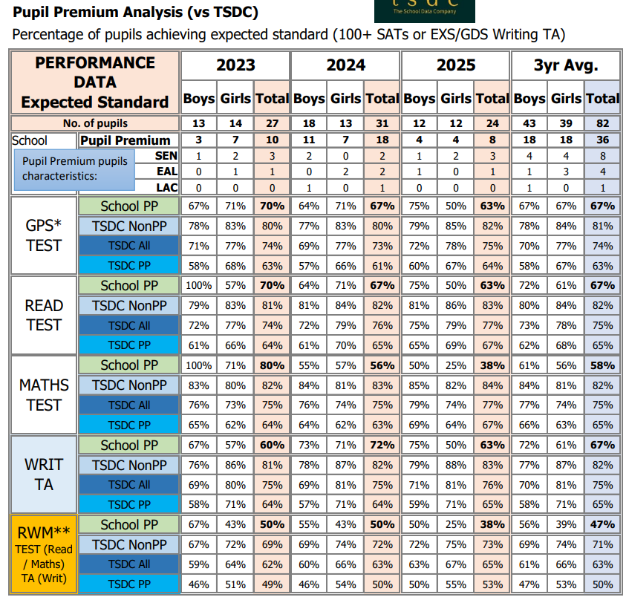

Outcome 1: Most disadvantaged children to achieve the expected level or beyond in reading, writing and maths in line with national expectations and their peers.
63% of PPG children achieved at least expected in Reading and Writing – at least in line with national PPG children. The number of PPG children achieving expected+ in mathematics was 38%, a gap of 23% from national disadvantaged and 42% to national other.
Outcome 2: Resilient and confident learners who persevere when faced with a challenge.
PPG children had a attainment gap of -7% in maths high scores, -27% gap in reading and -16% gap in writing.
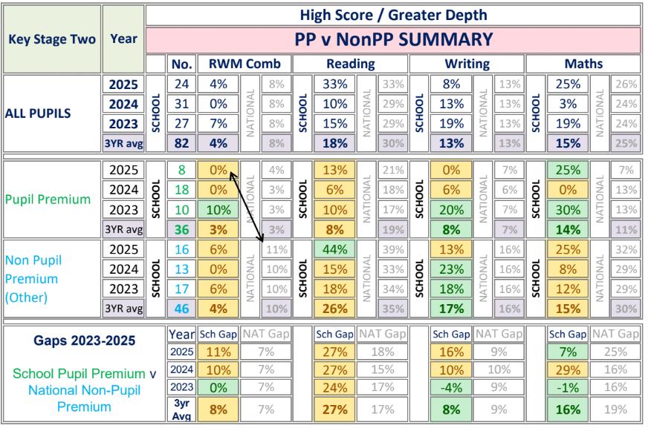

Outcome 3: Pupil’s starting points entering EYFS are significantly below where they should be.
The attainment gap between PPG and Non-PPG (national) was -16%, better than national PPG children which was -20%, and vastly improving on the previous gap of -52%

GLD Data:
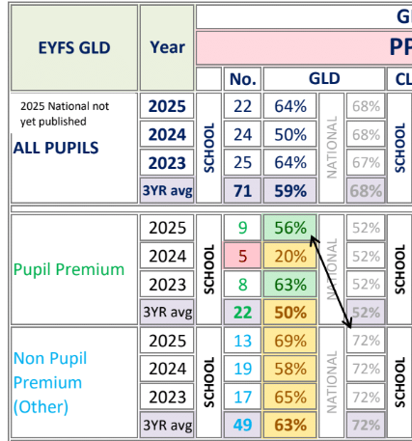

Outcome 4: Improvement in attendance to match non-disadvantaged
The attendance rate for pupils eligible for Pupil Premium funding was 94.3%, compared to 95.2% for non-Pupil Premium pupils. This indicates a gap of 0.9 percentage points, highlighting the need for continued focus on improving attendance among Pupil Premium pupils. This has increased from the previous year (23/24) 93.9%, demonstrating that the gap is closing.

Externally provided programmes
Please include the names of any non-DfE programmes that you used your pupil premium to fund in the previous academic year.
Programme | Provider
Reading Plus | Reading Solutions UK
Grammarsaurus | Grammarsaurus
Little Wandle | Letters and Sounds revised /Big Cat publishers
White Rose Maths | White Rose Maths

Service pupil premium funding (optional)
For schools that receive this funding, you may wish to provide the following information: How our service pupil premium allocation was spent last academic year
The impact of that spending on service pupil premium eligible pupils

Further information (optional)
Use this space to provide any further information about your pupil premium strategy. For example, about your strategy planning, implementation and evaluation, or other activity that you are delivering to support disadvantaged pupils that is not dependent on pupil premium funding.

