Reading in Year 5

In Year 5 children should be read widely and frequently, outside as well as in school, for pleasure and information. They should be able to read silently, and then discuss what they have read.

Pupils are taught comprehension explicitly through the use of Reading Explorers; a skills-based approach to the teaching and learning of key aspects of Literacy within the classroom. This approach teaches reading through a wide variety of genres, both fiction and non-fiction, which will allow children to access, interpret and understand what they are reading. It increases the child’s knowledge and understanding of why certain words are chosen by an author. It gives the reader the chance to speculate on the tone and purpose of the texts, as well as consider both texts’ themes and audience.

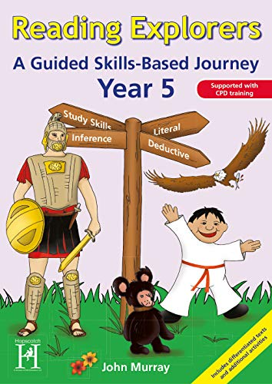

The five thinking and reasoning skills taught are: literal thinking; deductive reasoning; inferential skills; evaluative assessment of texts; and study skills which promote wider independent study.

**A Love of Reading and Parental Engagement**

Reading has high priority throughout school. Books, from a school book spine, are read to pupils by their teachers. Pupils are rewarded for their reading through a range of age appropriate class rewards. Every child has a reading record and teachers praise pupils and inform parents of progress using a parental engagement app, parent meetings and regular data captures. We take every opportunity to celebrate reading through events such as: World Book Day and Story Swaps.

**Standards and Attainment**

Pupils make maximum progress in phonics and reading through a range of planned assessment opportunities. Regular ongoing assessment and more formal assessment informs teachers and leaders of pupil progress which is shared with parents and governors.  Groupings are closely monitored and children move groups based on their attainment.  Intervention groups are planned based on assessments.

**High Quality Teaching and Learning**

The English leader ensures that all staff have high quality training up to date training so that they are experts at teaching reading. Leaders, in school and across the trust, monitor and moderate to ensure high quality teaching and assessment.