ZETLAND PRIMARY SCHOOL

ZETLAND PRIMARY SCHOOL

UNIFORM POLICY

Issue Date | October 2022
Review Date: | June 2024
Author: | Paul Richardson

School Uniform

The School policy towards the wearing of uniform allow our children to demonstrate respect for our School, as well as help eliminate problems caused by bullying around fashion, money and taste. They help our children view their school as a community of equals.
All pupils wear uniform that matches Zetland Primary School colours.
Children from Foundation Stage Nursery through to Year 6 wear a pale blue polo shirt, with grey trousers, shorts, skirts or pinafore or a gingham dress in blue and a burgundy sweatshirt or cardigan. Many parents choose to have their child’s initials on the front of their clothing.
Children should wear plain black shoes with no visible logo.

In order to keep costs as low as we can we have an official supplier - Quickastitch. Additionally, you are welcome to select unbadged clothing, albeit in the school colours. If you so wish, these are readily available in most supermarkets, or through second-hand resellers.

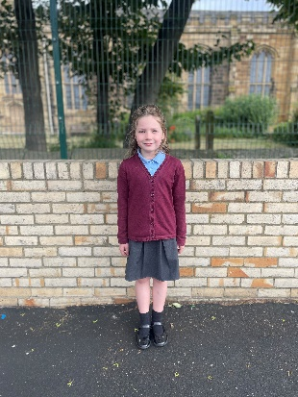 | 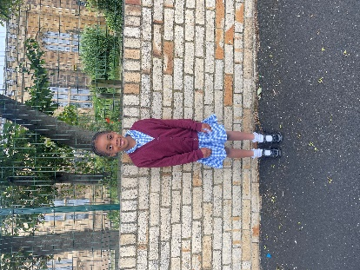 | 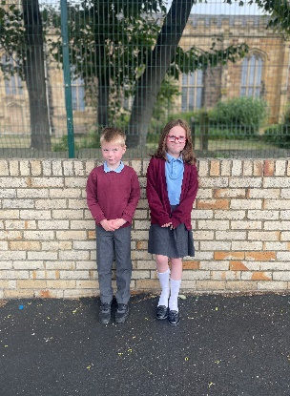 | 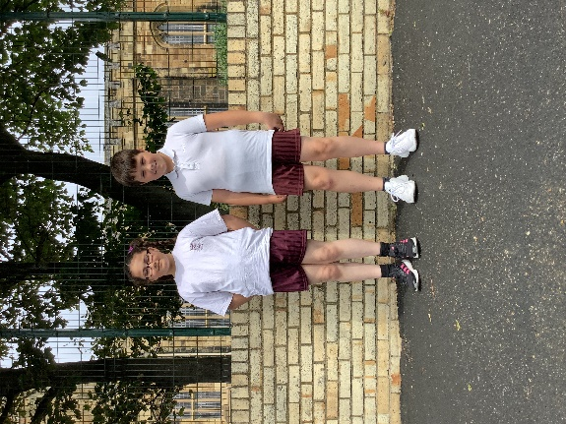

PE Kit

Your child must have a PE kit of maroon shorts, plain white T shirt (not a football shirt) and plimsolls or trainers, kept in a PE bag and in school on every day. An outdoor kit is also required during colder months; most parents add a burgundy school jumper or hoodie and black joggers, possibly some older trainers.

Please ensure your child remembers to bring their kit to School on Monday, to save you the inconvenience of you having to bring it to school for your child’s lessons during the week. PE kits may be left in school between lessons.

Children having swimming lessons will also need a swimming costume (not bikini) or swimming trunks (not shorts) and a towel.

Jewellery

The wearing of all cosmetic jewellery is not allowed, although older children may wear a watch (not a smart watch). Children can wear small stud-type earrings in school. They must be removed independently for all PE activities. If you wish your child to have their ears pierced, please ensure this is done at the start of the six-week summer holiday break.

Hair styles

Long hair should be tied back, and the School discourages some specific hairstyles, for example shaved lines or coloured hair. Please discuss your proposed haircut with the Head teacher before having it cut if in doubt!

Questions?

Please contact the Head teacher.

I hope these rules are simple and fair; any questions please ask. Religious or faith based clothing is perfectly acceptable, following the spirit of the guidance above.

Please see below link for Government guidance on school uniform.
https://www.gov.uk/government/publications/cost-of-school-uniforms/cost-of-school-uniforms

