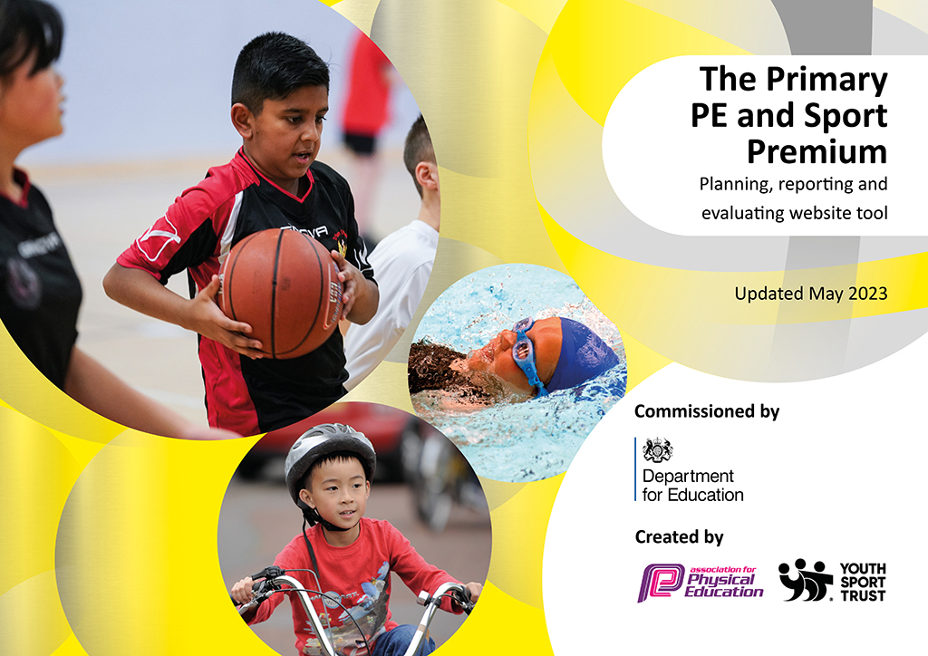
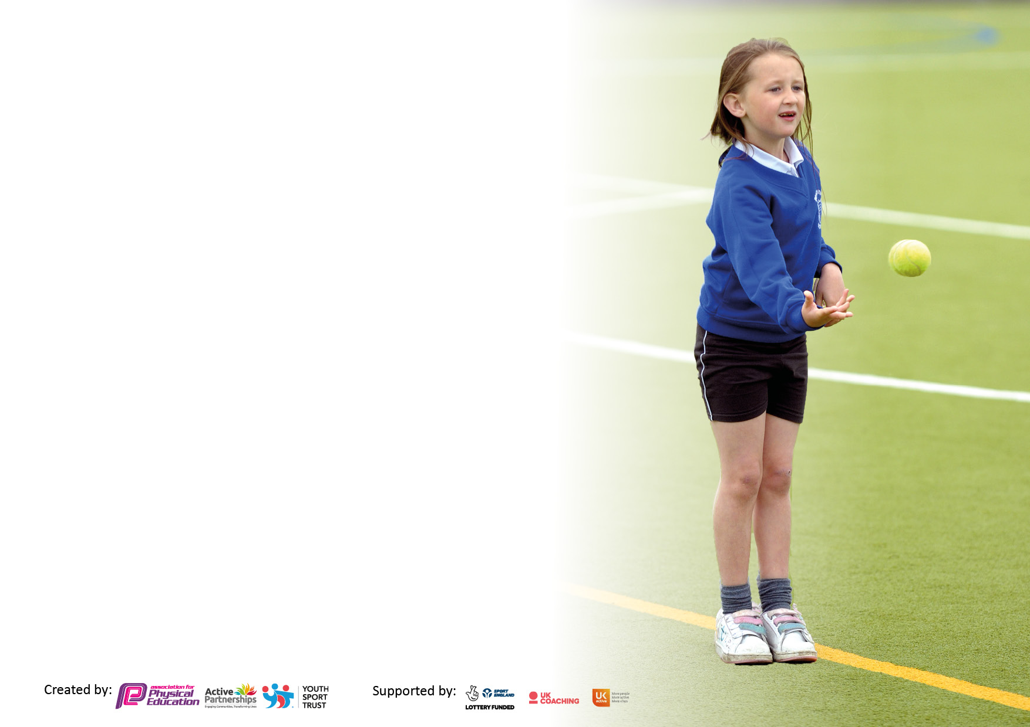

It is important that your grant is used effectively and based on school need. The Education Inspection Framework makes clear there will be a focus on ‘whether leaders and those responsible for governors all understand their respective roles and perform these in a way that enhances the effectiveness of the school’.

Under the Quality of Education judgement, Ofsted inspectors consider:
Intent - Curriculum design, coverage and appropriateness
Implementation - Curriculum delivery, teaching (pedagogy) and assessment
Impact - Attainment and progress

To assist schools with common transferable language, this template has been developed to utilise the same three headings which should make your plans easily transferable between working documents.

Schools must use the funding to make additional and sustainable improvements to the quality of Physical Education, School Sport and Physical Activity (PESSPA) they offer. This means that you should use the Primary PE and sport premium to:

- Develop or add to the PESSPA activities that your school already offers
- Build capacity and capability within the school to ensure that improvements made now will benefit pupils joining the school in future years
- The Primary PE and sport premium should not be used to fund capital spend projects; the school’s budget should fund these.

Please visit https://www.gov.uk/guidance/pe-and-sport-premium-for-primary-schools for the revised DfE guidance, including the 5 key indicators across which schools should demonstrate an improvement. This document will help you to review your provision and to report your spend. DfE encourages schools to use this template as an effective way of meeting the reporting requirements of the Primary PE and Sport Premium.

We recommend you start by reflecting on the impact of current provision and reviewing the previous spend.

Schools are required to publish details of how they spend this funding, including any underspend from 2021/2022, as well as on the impact it has on pupils’ PE and sport participation and attainment.

We recommend regularly updating the table and publishing it on your website throughout the year. This evidences your ongoing self-evaluation of how you are using the funding to secure maximum, sustainable impact. Final copy must be posted on your website by the end of the academic year and no later than the 31 July 2023.

Details with regard to funding
Please complete the table below.

Total amount carried over from 2021/22 | £0
Total amount allocated for 2022/23 | £17710
How much (if any) do you intend to carry over from this total fund into 2023/24? | £0
Total amount allocated for 2022/23 | £17710
Total amount of funding for 2022/23 to be reported on by 31st July 2023 | £17710
Swimming Data
Please report on your Swimming Data below.

Meeting national curriculum requirements for swimming and water safety.

N.B. Complete this section as best you can. For example, you might have practised safe self-rescue techniques on dry land which you can then transfer to the pool when school swimming restarts.
Due to exceptional circumstances priority should be given to ensuring that pupils can perform safe self-rescue even if they do not fully meet the first two requirements of the NC programme of study
What percentage of your current Year 6 cohort swim competently, confidently and proficiently over a distance of at least 25 metres?  N.B. Even though your pupils may swim in another year, please report on their attainment on leaving primary school at the end of the summer term 2023.  Please see note above | 63%
What percentage of your current Year 6 cohort use a range of strokes effectively [for example, front crawl, backstroke and breaststroke]?  Please see note above | 63%
What percentage of your current Year 6 cohort perform safe self-rescue in different water-based situations? | 100%
Schools can choose to use the Primary PE and sport premium to provide additional provision for swimming, but this must be for activity over and above the national curriculum requirements. Have you used it in this way? | Yes (After school swim weekly club 10-12 sessions per child)

Action Plan and Budget Tracking
Capture your intended annual spend against the 5 key indicators. Clarify the success criteria and evidence of impact that you intend to measure to evaluate for pupils today and for the future.

Academic Year: 2022/23 | Total fund allocated: | Date Updated:
Key indicator 1: Increase confidence, knowledge and skills of all staff in teaching PE and sport |  |  |  | Percentage of total allocation:
 |  |  |  | %
Intent | Implementation |  | Impact
Your school focus should be clear on what you want the pupils to know and be able to do. What do they need to learn and to consolidate through practice: | Make sure your actions to achieve are linked to your intentions: | Funding allocated: | Evidence of impact:  What do pupils now know and what can they now do? What has changed? | Sustainability and suggested next steps:
Increase knowledge and understanding and confidence and competence of staff. | Provide ongoing training and support to all staff.  Staff audit of skill and areas to develop.  Staff to have access to RESSP CPD opportunities. Timetable of courses emailed out.  SM book staff onto appropriate training. | Part of RESSP buy in. (Part of £4,500) | Impact to be monitored throughout the year and reported on in July. | To be completed at the end of the academic year.
High quality sequences of learning delivered. | Whole school use of Complete P.E  SM to review planning regularly  Use school coaching staff to deliver a high level of PE across KS2 TA to support, developing their skills and knowledge. | £9200 coaching staff | Impact to be monitored throughout the year and reported on in July.  Having 2 coaching staff on school staff enables a continuous delivery of PE throughout the school year. Assessments, children’s health and knowledge. | To be completed at the end of the academic year.
Key indicator 2: The engagement of all pupils in regular physical activity – Chief Medical Officers’ guidelines recommend that  primary school pupils undertake at least 30 minutes of physical activity a day in school |  |  |  | Percentage of total allocation:
 |  |  |  | %
Intent | Implementation |  | Impact
Your school focus should be clear on what you want the pupils to know and be able to do. What do they need to learn and to consolidate through practice: | Make sure your actions to achieve are linked to your intentions: | Funding allocated: | Evidence of impact:  What do pupils now know and what can they now do? What has changed? | Sustainability and suggested next steps:
Develop the knowledge and understanding of all staff regarding the importance of 60 active minutes.  Provide a range of activities - implementation of new extracurricular timetable created by pupil voice. Increase the number of clubs for children to attend therefore increase participation. | Book in RESSP to deliver Active 60 minutes staff training in a twilight session.  Subject Leader & Head Teacher to advocate the importance of keeping children active. | Course Cost: Part of RESSP Buy in. (Part of £4,500) | Staff have the knowledge and understanding why children should be active and that it links to their educational achievements, health, physical development and mental wellbeing.  Staff have implemented physical activity into their planning. | Each year make sure that new staff are trained.  Subject leader to ensure staff do not revert back to sedentary classrooms.  New ideas refreshed to keep up interest for staff and children.
Staff to have a range different of resources to help deliver 60 active minutes through the school’s, ‘Active 30:30’ approach. | Resources to be saved in the shared area for staff to access.  New ideas to be added throughout the year with support from RESSP.  Purchase resources needed to deliver in the classroom. | £0  Part of RESSP buy in. Part of  £4,500)  £248 | Staff are more confident to ensure active lessons are delivered. | Resources are accessible and shared.  A bank of resources is built up.
Promote physical activity at home and have the support from parents.  Greater understanding of the importance of being active. | P.E home learning is set through Seesaw- complete P.E 60 second activities.  Koboca to be promoted across school- half termly.  The importance of being physically active at home is promoted. | £0  Part of RESSP buy in. (Part of  £4,500) | Impact to be monitored regularly throughout the year. | Continue to raise the profile of the importance of PE, school sport and physical activity. Promoting this regularly throughout the year and each new school year.  Promote physical activity opportunities for families outside of school
Ensure children have access to age-appropriate active travel training to encourage children to walk or cycle to school safely. | Year 3 pupils take part in Pedestrian training to learn how to cross the road safely.  Y5 & 6 pupils take part in Bikeability Level 1 & 2 training to learn how to ride their bikes safely on the road  Active travel promotion to parents and families in school newsletters and parent meetings.  Identify children and offer Learn to Ride sessions for those children in year 5 and 6 who can’t ride a bike. | Bikeability Training Cost: Part of RESSP Buy in. (Part of £4,500).  Pedestrian Training Cost: 30 children = £90 | In Sept 2021 50% of children travelled to school by walking or cycling or scooting.  In July 2022 95% of children travel to school by walking or cycling or scooting.  Children are more awake on a morning.  Less congestion at the school gate for drop off and pick up times.  Children are more confident and competent to ride on roads and cross the roads safely. | Each year the next cohort will be trained.  School staff supporting the instructors from the RESSP fully understand the outcomes and consolidate this learning back in school.  Parents understand the school is an ‘active school’ and the benefits of walking their child to school and spending quality time on a morning.
Promote physical activity at break and lunch times, through the use of play leaders. | Play leaders to be present at break and lunchtimes.  PE team to organise Play leader training through RESSP and a timetable to be set up.  Equipment to be purchased to ensure appropriate resources are available for each year group. | Part of RESSP buy in. (Part of  £4,500)  £248 (as above) | Impact to be monitored throughout the year and reported on in July. | Play leaders and PE team to ensure equipment is used appropriately and stored correctly.

Key indicator 3: The profile of PE and sport is raised across the school as a tool for whole school improvement |  |  |  | Percentage of total allocation:
 |  |  |  | %
Intent | Implementation |  | Impact
Your school focus should be clear on what you want the pupils to know and be able to do. What do they need to learn and to consolidate through practice: | Make sure your actions to achieve are linked to your intentions: | Funding allocated: | Evidence of impact:  What do pupils now know and what can they now do? What has  changed? | Sustainability and suggested next steps:
Develop leadership skills in children | RESSP trained sports leaders.  A member of staff accompanied the children to the training and now leads the sports leaders’ team within school.  The children deliver physical activity sessions at break and lunchtimes.  The member of staff in charge meets the leaders once a month to plan activities and to use the group as the student voice for other projects.  The leaders will also support events organised by RESSP. | Leadership Training Cost: Part of RESSP Buy in. (Part of £4,500). | Pupils have increased self-esteem and confidence.  Young leaders benefit from the experience of planning,  organising and delivering a range of sports to a diverse group of children. They became more confident in their leadership qualities. Children attend training.  Staff benefit from training by RESSP so they understand their role back at school with the sports leaders.  A more active school has been achieved by having the ‘mini workforce’ at break with in own year group from y3 up over and lunchtimes y6 with KS1 children. | 20 Sports leaders from Y5 currently trained and 20 from y5 to attend training. We need to continue this year on year and have the older leaders mentor the younger ones.
Spirit of the Games Golden half termly focus to be launched throughout school.  Celebrate the whole child not just physical skills.  Physical Education used to improve behaviour. | Introduce the Spirit of the Games values to all children.  All staff work with SSP promoting these values in school, during PE lessons and when taking part in SSP competitions and festivals.  Share with parents on newsletter, Marvellous Me, Twitter and Seesaw. | Part of RESSP buy in. (Part of £4,500) | Impact to be monitored throughout the year and reported on in July. | To be completed at the end of the academic year.
Develop the life skills in pupils. | My Personal Best to be used as a tool to develop life skills across the whole curriculum.  SM to included My Personal Best life skills to the curriculum map for the whole school-add to over the year.  Whole school training to share resources with whole school.  Develop a working wall displaying the key life skills taught in the different key stages.  SM, LM, CR attend My Personal Best training. | £105  Complete P.E  My personal best course fees  £200 | Impact to be monitored throughout the year and reported on in July. | To be completed at the end of the academic year.
Key indicator 4: Broader experience of a range of sports and physical activities offered to all pupils |  |  |  | Percentage of total allocation:
Intent | Implementation |  | Impact
Your school focus should be clear on what you want the pupils to know and be able to do. What do they need to learn and to consolidate through practice: | Make sure your actions to achieve are linked to your intentions: | Funding allocated: | Evidence of impact:  What do pupils now know and what can they now do? What has  changed? | Sustainability and suggested next steps:
To ensure that all children and young people enjoy some form of sport or physical activity | Take part in RESSP festivals and development days.  Whole school sports day  After school club timetable to be set up and promoted throughout school.  Introduce KS1 club- LM to run | Festival & Development Days Cost: Part of RESSP buy in (Part of £4,500). | The children are engaged more in PE and after school clubs due to the wider and broader selection of activities | Continue to enter children into sports events and festivals.  Ensure thought goes into which children are selected for which event.
Ensure that children understand where they can participate further in a sport or activity outside of school  Children will experience a club setting and know exit routes to take. | Link to local sports clubs – Grangetown Netball Club, Redcar Rugby Club, Redcar Cricket club, Redcar Athletics football club.  The clubs offer taster sessions or after school clubs.  Redcar Gymnastic Club visit- All KS2 children will attend the gym club in the Autumn term at the end of their gymnastics unit of work.  Whole school golf experience day  Share exit route provided by the RESSP with children/ parents through Seesaw after events. | KS2- Gym day-  £200  £180 | Children have an increased awareness of different activities outside of school. | We need to increase the links to include a wider variety of sports and activities.
Ensure that all children know how to and are confident and competent to ride a bike | Balance bike training for all children in Reception, delivered by RESSP.  Learn to Ride- Identify children and offer Learn to Ride sessions for those children in year 5 and 6 who can’t ride a bike. | Balance Bike Training Cost: £3 per child x 30 children = £90  £200  30 min-60mins per child | Guidance has gone home to parents about balance bike training and their child’s next steps. | To be completed at the end of the academic year.
Ensure children are given the opportunity to learn to swim. | Year 3 and 4 to attend 1.5 terms of weekly swim sessions.  After school swimming lessons to be offered to KS2 children who cannot swim 25m. | £165 | Impact to be monitored throughout the year and reported on in July. | To be completed at the end of the academic year.

Key indicator 5: Increased participation in competitive sport |  |  |  | Percentage of total allocation:
 |  |  |  | %
Intent | Implementation |  | Impact
Your school focus should be clear on what you want the pupils to know and be able to do. What do they need to learn and to consolidate through practice: | Make sure your actions to achieve are linked to your intentions: | Funding allocated: | Evidence of impact:  What do pupils now know and what can they now do? What has  changed? | Sustainability and suggested next steps:
Ensure that every pupil, by the time they reach Y6, has represented their school in an intra and inter sporting activities. | Enter into RESSP competitions and festivals.  Ensure children are entered into appropriate levels of competition to suit their individual motivation, competence and confidence levels.  Celebrate ALL participation achievements, not just the winners | Competition Cost: Part of RESSP buy in (Part of £4,500)  Transport to events- £2500 | Pupils’ skills developed through the experience and some developed an interest in a new activity.  Pupils have a sense of belonging to their school as they represented the school.  Pupils have improved their confidence, competence, motivation, knowledge and understanding in various sports and activities.  Staff have benefitted from the professional development opportunities through attending events and learning from the deliverers. | Ensure that all children are appropriately prepared for the competition they are attending to further increase their physical literacy levels particularly their confidence and motivation levels.  Reinforce the Spirit of the Games values that RESSP are aiming to develop in our children: Honesty, Passion, Determination, Self-Belief, Respect and Teamwork.
Create an opportunity for every child to participate. | Create a tracking system to monitor  participation in inter school competitions.  SM, LM and CR to complete tracker in order to monitor participation in competitions, festivals and development days. This will help target children who are least active. | £0 | Impact to be monitored throughout the year and reported on in July. | To be completed at the end of the academic year.

Signed off by
Head Teacher: | Simon English
Date: | 17.7.23
Subject Leader: | Sue McCready
Date: | 17.7.23
Governor: | Shelia Leng
Date: | 17.7.23

