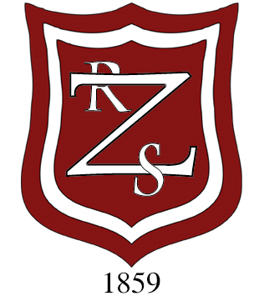

**ZETLAND PRIMARY SAFEGUARDING TEAM**

The welfare and safeguarding of children in Zetland Primary School is a high priority. If you have any concerns or would like to discuss any matters relating to this area please contact a member of the Safeguarding Team or contact school on 01642 484595. Further information can be found in our Child Protection information poster/booklet.

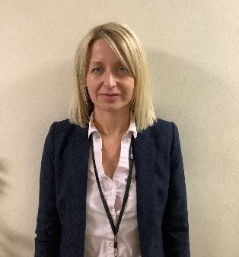

Miss Sarah Morrison: Head Teacher

Designated Safeguarding Lead



Mr Paul Richardson (KS2)

Deputy Designated Safeguarding Lead (DDSL)

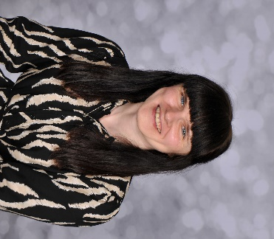

Miss Joanne Clarkson (KS1)

Deputy Designated Safeguarding Lead (DDSL)

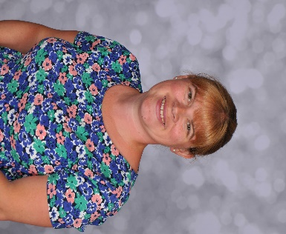

Mrs Miriam Fellows (EYFS)

Deputy Designated Safeguarding Lead (DDSL)

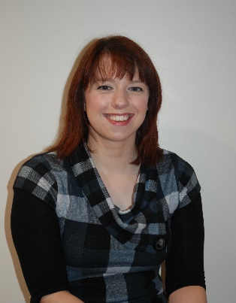

Mrs Beth McGlasson

Designated Safeguarding Governor (DSG)

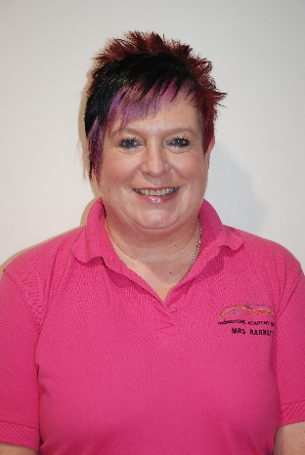

Mrs Julie Barnett

IAT Deputy Designated Safeguarding Lead (IAT DDSL)