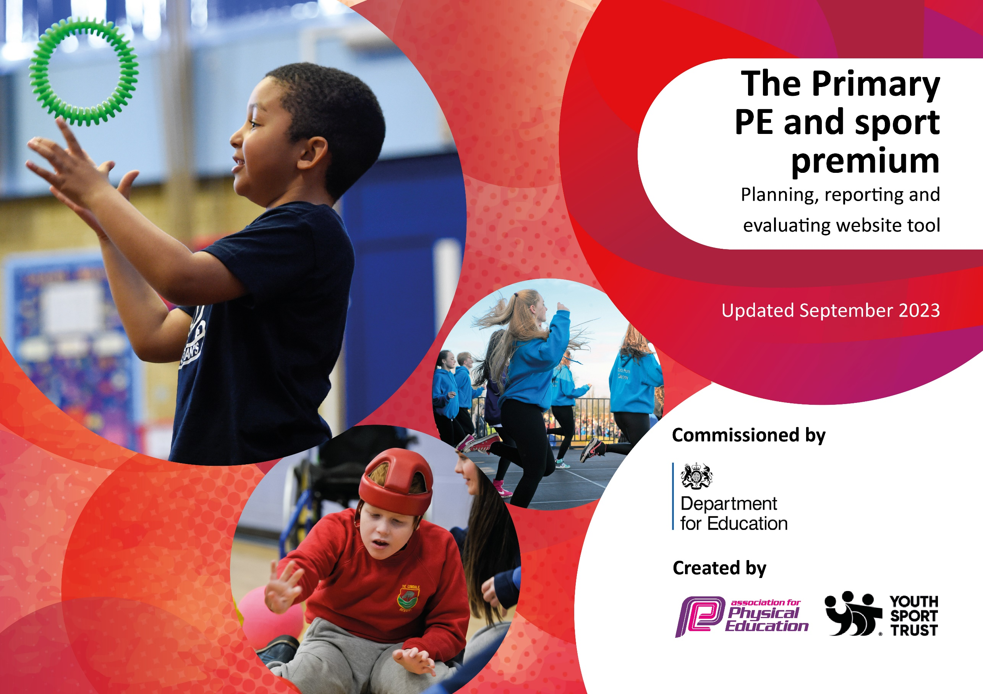

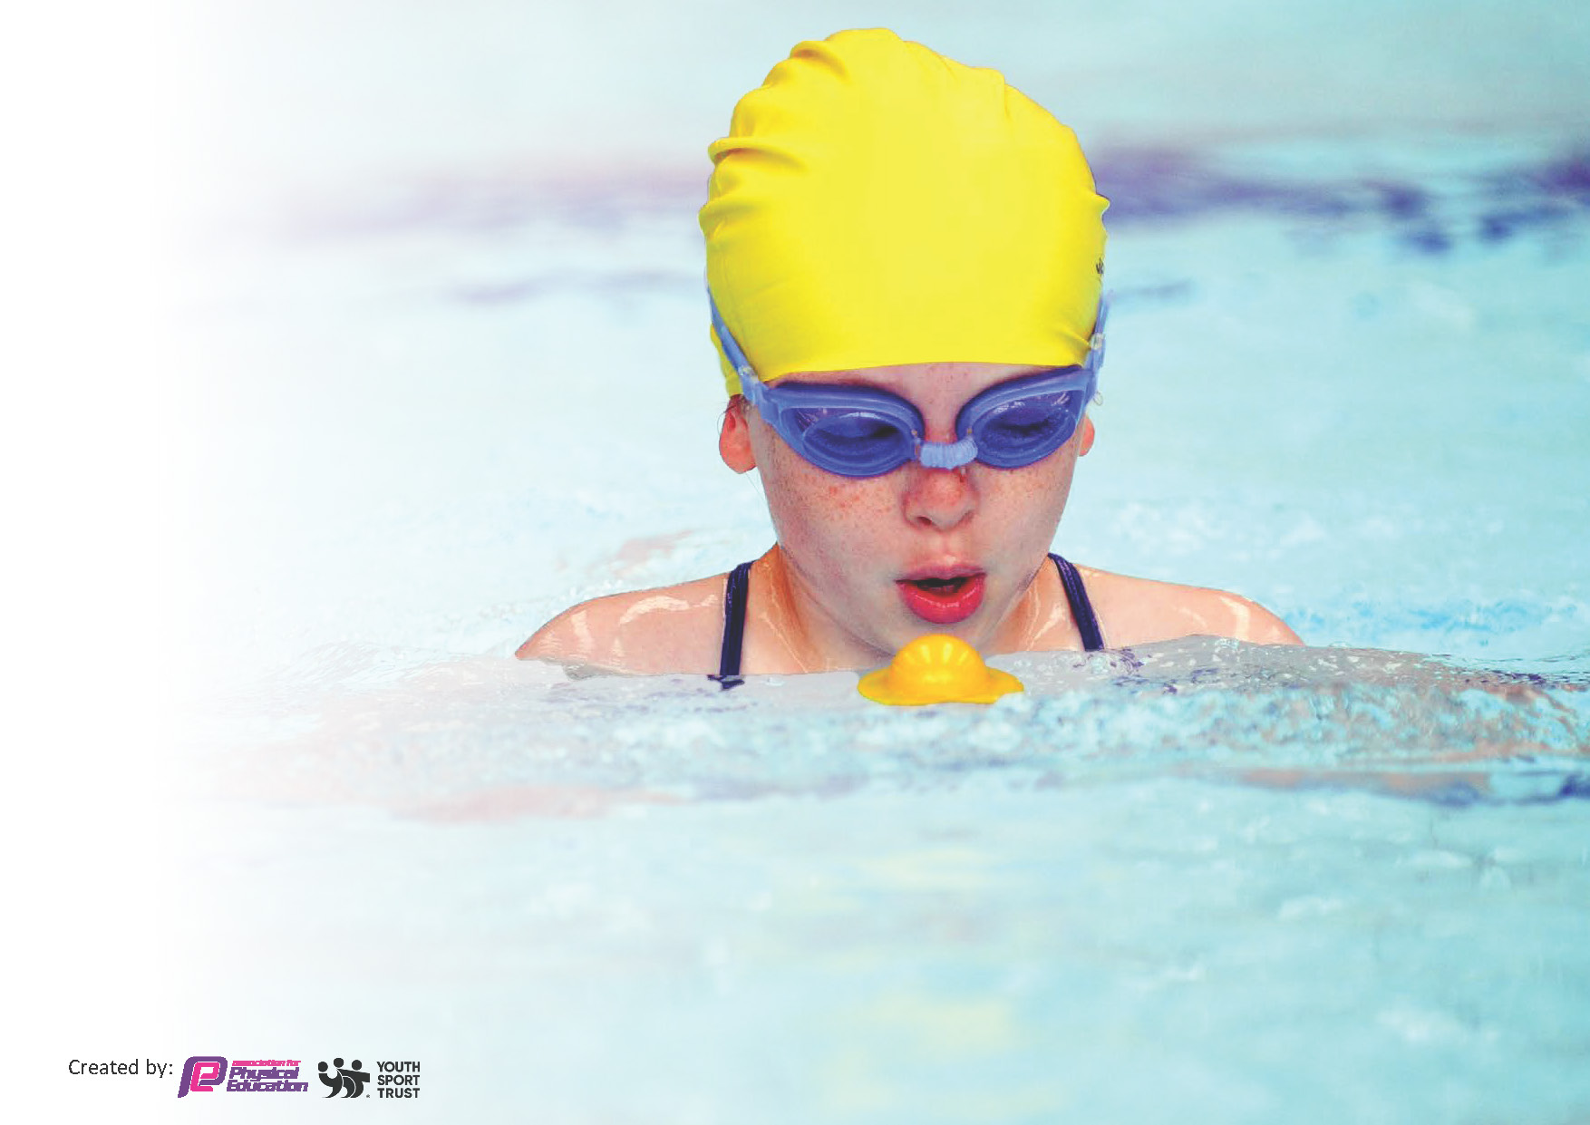
This template can be used for multiple purposes:
by:
- It enables schools to effectively plan their use of the Primary PE and sport premium
- It helps schools to meet the requirements (as set out in guidance) to publish information on their Primary PE and sport premium
- It will be an effective document to support Ofsted inspections enabling schools to evidence progress in Physical Education (PE) and evidence swimming attainment, which forms part of the PE National Curriculum. We would recommend schools consider
the Intent, Implementation and Impact of any spend, as examined within the Education Inspection Framework.

It is important that your grant is used effectively and based on school need.

Schools must use the funding to make additional and sustainable
improvements to the quality of the PE, School Sport and Physical Activity (PESSPA)
they offer. This means that you should use the Primary PE and sport premium to:

- Build capacity and capability within the school to ensure that improvements made now will benefit pupils joining the school in future years
- Develop or add to the PESSPA activities that your school already offers.

The Primary PE and sport premium should not be used to fund capital spend projects; the school’s core budget should fund these. Further detail on capital expenditure can be found in the updated Primary PE and sport premium guidance.

The Primary PE and sport premium guidance, outlines 5 key priorities that funding should be used towards. It is not

necessary that spending has to meet all the key priorities, you should select the priorities that you aim to use any funding towards.

Although completing this template is not a requirement for schools, schools are required to publish details of how they spend this funding. Schools must also outline what the impact this funding has had on pupils’ PE and sport participation and attainment and how any spending will be sustainable in the future. All funding must be spent by 31st July 2024.

The Department for Education has worked closely with the Association for Physical Education (afPE) and the Youth Sport Trust (YST) to develop this template and encourages schools to use it. This template is an effective way of meeting the reporting requirements of the Primary PE and sport premium.
Review of last year’s spend and key achievements (2022/2023)

We recommend you start by reflecting on the impact of current provision and reviewing your previous spend.

Activity/Action | Impact | Comments
Develop the knowledge and understanding of all staff regarding the importance of 60 active minutes.  Provide a range of activities - implementation of new extracurricular timetable created by pupil voice. Increase the number of clubs for children to attend therefore increase participation.  Staff to have a range different of resources to help deliver 60 active minutes through the school’s, ‘Active 30:30’ approach.  Promote physical activity at home and have the support from parents.  Greater understanding of the importance of being active.  Ensure children have access to age-appropriate active travel training to encourage children to walk or cycle to school safely.  Develop the life skills in pupils.  My Personal Best to be used as a tool to develop life skills across the whole curriculum.  SM to included My Personal Best life skills to the curriculum map for the whole school-add to over the year.  Whole school training to share resources with whole school.  Develop a working wall displaying the key life skills taught in the different key stages.  SM, LM, CR attend My Personal Best training. | Staff have the knowledge and understanding why children should be active and that it links to their educational achievements, health, physical development and mental wellbeing.  Staff have implemented some physical activity into their planning.  Staff are more confident to ensure active lessons are delivered.  The whole school community will understand the importance of PE, school sport and physical activity.  Promote physical activity opportunities for families outside of school  Children are more confident and competent to ride on roads and cross the roads safely.  My personal best life skills are embedded in the curriculum and are used to develop life skills across the whole school.  Children understand the life skills and recognise how they link to everyday life. | Staff have a good understanding of the importance but more work is needed to ensure children are more active.  Needs to be evident across school. Hall timetable to allow classes to use the space for other areas of learning not just P.E.  Recourses to be saved in the shared area so staff have a bank to access.  The sport and physical activity that takes place needs to be prompted regularly throughout the year and each new school year. (newsletters, seesaw, notice boards)  Children were identified and offered the Learn to Ride sessions for those children in year 5 and 6 who can’t ride a bike. This had a great uptake and we had many children learn to ride their bike confidently able to then progress onto the level one training in the next academic year.  The next step needs to be promoting active travel and encouraging children to actively travel to school reducing traffic congestion on Redcar Lane.  Course was attended but more work needs to be done in order to embed in to the curriculum across school.  Display updated to match the focus life skill for the half term.

Key priorities and Planning
This planning template will allow schools to accurately plan their spending.

Action – what are you planning to do | Who does this action impact? | Key indicator to meet | Impacts and how sustainability will be achieved? | Cost linked to the action
Create a folder on the shared area for staff to access easily containing ideas for active lesson breaks | Teaching staff as they use resources  Pupils as they take part | 1- increasing all staff’s confidence, knowledge and skills in teaching PE and sport  2  3- raising the profile of PE and sport across the school, to support whole school improvement | More pupils meeting their daily physical activity goal, more pupils encouraged to take part in PE and Sport Activities. School sports raised across school. Staff confidence increased.
Introduce new lunchtime sport sessions/activities for pupils lead by play leaders. | Lunchtime supervisors / breaktime staff/ Sports leaders - as they need to lead the activity  pupils – as they will take part. | 2 -The engagement of all pupils in regular physical activity – the Chief Medical Officer guidelines recommend that all children and young people aged 5 to 18 engage in at least 60 minutes of physical activity per day, of which 30 minutes should be in school.  4- Broader experience of a range of sports and activities offered to all pupils. | More pupils meeting their daily physical activity goal, more pupils encouraged to take part in PE and Sport Activities. | £ 300 costs for resources to support lunchtime/ playtime sessions.
Raise understanding of physical literacy across the whole school. | Staff knowledge and understanding  Pupils develop a greater understanding of PE and engagement is raised. | 1, 2, 3, 4 | Staff and Pupils have a better understanding of Physical Literacy they are-  Confident, competent, motivated, knowledge and understanding.
Youth Voice consultation- ask children what they want to do in afterschool sport/ intra sports events. | Pupils | 2, 4,  5-increase participation in competitive sport | Greater attendance- more pupils accessing a range of sports. More pupils meeting the daily physical goal.
Target opportunities for those children who need it most linked to youth voice consultation | Pupils who attend sessions | 2, 4 | Engage the disengaged through allocating opportunities based on pupil voice feedback.
Embed My Personal Best into the Curriculum- one per half term. Share resources with staff and update display board with focus life skill. | Staff- when delivering PE  Pupils learning and understanding new life skills. | 1, 3, | Children understand what life skills are, what each of them mean and can articulate how developing them can help in PE the classroom and outside of school. | Cost of Complete P.E-  £126
Engage parents through regular updates of Sport in Zetland including intent. | Parents have a greater understanding of school sports. | 3 | Parents understand the opportunities and experiences in school.  Profile of school sports is raised across the whole school.
Increase active travel across the school- through work with the partnership to create an active travel scheme. | Pupils who actively travel | 2, 4 | More children will actively travel to school. More pupils meeting their daily physical activity goal
Increase knowledge and understanding and confidence and competence of staff.  Provide ongoing training and support to all staff.  Staff audit of skill and areas to develop.  Staff to have access to RESSP CPD opportunities. Timetable of courses emailed out.  SMc book staff onto appropriate training. | Staff and Pupils | 1 | Staff will have an increased knowledge and understanding and confidence and competence. | Part of RESSP buy in. (Part of £4,500)
High quality sequences of learning delivered.  Whole school use of Complete P.E  SMc to review planning regularly.  Use school coaching staff to deliver a high level of PE across KS2 TA to support, developing their skills and knowledge. | Staff and pupils | 1 , 2, 3 | Having 2 coaching staff on school staff enables a continuous delivery of PE throughout the school year. Assessments, children’s health and knowledge. After school sport is delivered at a high standard and more children will reach the expected active minutes. | Coaching staff
Ensure that all children know how to and are confident and competent to ride a bike Year 3 pupils take part in Pedestrian training to learn how to cross the road safely.  Y5 & 6 pupils take part in Bikeability Level 1 & 2 training to learn how to ride their bikes safely on the road  Ensure that all children know how to and are confident and competent to ride a bike  Balance bike training for all children in Reception, delivered by RESSP.  Learn to Ride- Identify children and offer Learn to Ride sessions for those children in year 5 and 6 who can’t ride a bike. | Staff and pupils | 2 | Each year the next cohort will be trained.  School staff supporting the instructors from the RESSP fully understand the outcomes and consolidate this learning back in school.  Parents understand the school is an ‘active school’ and the benefits of walking their child to school and spending quality time on a morning. | Pedestrian Training Cost: 30 children = £90  Balance Bike Training Cost: £3 per child x 30 children = £90  £200  30 min-60mins per child
Top up swimming sessions to ensure children are given the opportunity to learn to swim.  After school swimming lessons to be offered to KS2 children who cannot swim 25m.  Year 6 extra sessions | Non – swimmers | 2, 4 | Greater number of children able to swim 25 meters before leaving primary school. | £200- coaches and school staff

Key achievements 2023-2024
This template will be completed at the end of the academic year and will showcase the key achievements schools have made with their Primary PE and sport premium spending.

Activity/Action | Impact | Comments

Swimming Data
Meeting National Curriculum requirements for swimming and water safety.
Priority should always be given to ensuring that pupils can perform safe self-rescue even if they do not fully meet the first two requirements of the National Curriculum programme of study

Question | Stats: | Further context  Relative to local challenges
What percentage of your current Year 6 cohort can swim competently, confidently and proficiently over a distance of at least 25 metres? | % | Use this text box to give further context behind the percentage.  e.g., 30% - we are struggling to get pool space due to our local pool closing so we have had to use a much smaller local school pool. We have had to limit the number of pupils attending swimming lessons during one term which means some pupils have attended fewer swimming lessons than others.
What percentage of your current Year 6 cohort can use a range of strokes effectively [for example, front crawl, backstroke, and breaststroke]? | % | Use this text box to give further context behind the percentage.  e.g., Even though your pupils may swim in another year please report on their attainment on leaving primary school at the end of the summer term 2024

What percentage of your current Year 6 cohort are able to perform safe self-rescue in different water-based situations? | % | Use this text box to give further context behind the percentage.
If your schools swimming data is below national expectation, you can choose to use the Primary PE and sport premium to provide additional top-up sessions for those pupils that did not meet National Curriculum  requirements after the completion of core lessons. Have you done this? | Yes/No | Weekly afterschool top up sessions across the year- always oversubscribed.  Year 6- block off sessions top up sessions
Have you provided CPD to improve the knowledge and confidence of staff to be able to teach swimming and water safety? | Yes/No

Signed off by:

Head Teacher: | Miss Sarah Morrison
Subject Leader or the individual responsible for the Primary PE and sport premium: | Sue McCready  P.E Leader
Governor: | Mrs Shelia Leng
Date: | October 2023

